From Farm to Factory

SECTION 1. BUTTER MAKING – A DOMESTIC INDUSTRY

The process of making butter is thought to be over two thousand years old and has not changed, in essence, from that day to this. The cream, which forms approximately 12%(1/8) of the milk, is separated from the milk. The cream is then beaten, shaken or agitated in some way, creating small lumps of butter and a milk liquid residue, called buttermilk.

The first section of this worksheet relates to the ground floor of the Museum – a plan of each part of the Museum is included at the back of this worksheet.

1. Look at the Information Panel “Butter Making on the Farm”.

- Can you give some reasons why you can tell this is an old photograph?

2. In the photograph at the bottom of the panel, the woman is using implements to shape the butter. Examples of these tools are on display in the Museum.

  - Locate the display case in which these tools are and write down what they are called

  - Draw one of them

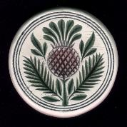 | There is a butter print in the bottom photograph on the panel and there are butter prints on display in this Museum. | 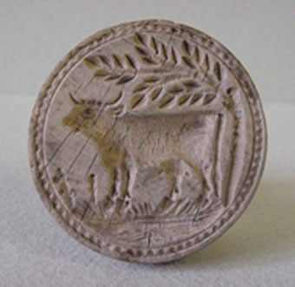

3. Locate the display case marked X on the museum with the butter prints

  - How many butter prints are on display?

Move to the display of traditional butter making equipment in the Museum - a plan of each part of the Museum is included at the back of this worksheet

Much of the information you will need is on the small panels beside the objects, indicated by the symbol

4. Count the different types of churn on display in the Museum? How many different types are there?

5. The Plate Iron Milk Churn

The Plate Iron Milk Churn is different from the other churns on display in that it was not used to churn butter – it was used to store and transport milk.

- Why do you think that the milk churn could not be used for making butter?

The Barrel Churn
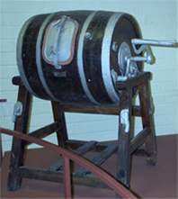 | (i) What is the capacity of the large barrel churn?
- If you were to fill the barrel Churn with 20 gallons of cream and that cream failed to churn into butter, how much milk would have been wasted. (N.B. – you have already been told, on the first page of this worksheet, how much cream is in milk.)

- Approximately what proportion of the year’s milk yield from the cow would be lost if the cream in the barrel churn were to fail?

Home butter makers did not understand the science of butter making; yet they knew well the difficulty of the task and the cost of failure.
As a result, there were many superstitions or piseogs attached to making.

Ash, salt or a horseshoe was placed near the churn as good luck. Churns were never lent to others. Fire could not be taken from the house when the milk was being churned.

5. The Butter Working Table | 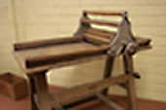

- What do you think the table was used for?

- Can you suggest why the table surface is sloped?

The Metal Skimming Pan

- How many hours did it take for the cream in the milk to rise to the top of the pan

- Can you suggest why cream rises to the top of the milk?

(Hint –Why does anything rise to the top of a liquid?)

- There is a limit to how wide a hand skimming pan can be. Why do you think this might be?

SECTION 2. BRINGING THE BUTTER TO MARKET –

THE BUTTER EXCHANGE

The Cork Butter Market, also called the Cork Butter Exchange, was Cork’s greatest commercial achievement. Starting in 1769 and continuing through the following century, the Butter Exchange created a system of quality control which was without comparison in Europe. The result was that the Cork Butter Exchange became the largest butter market in the world and the centre of a trade that stretched from West Kerry to Australia.

Go upstairs to the Gallery marked “Cork and the Butter Exchange” - a plan of each part of the Museum is included at the back of this worksheet

7. Look at the Information Panel “The Butter Roads”

- How long did the journey from Cork to Killarney take one hundred and fifty years ago?

- What dangers did the traveller face?

8. Look at the model of the “Butter Roads”
The “Butter Roads” is the name given to the roads which served the Butter Exchange, stories of which survived in the memory of people – the folk memory

- Name one of the rivers shown on the model.

- How many times does the road from Cahirciveen to Cork climb over the mountains?

- How many rivers does the road from Cahirciveen to Cork cross?

- How many times does the road from Cahirciveen to Cork cross a river?

9. Look at the panel “The Origins of the Cork Butter Museum”

- Name the counties from which butter was brought to Cork.

(

- The Cork Butter Exchange was established in 1769. Which of the following was true at that date?

 | TRUE | FALSE
The United States had been established
The Act of Union had been passed.
Napoleon was ruler of France

- The system in the Cork Butter Exchange was unique at the time Look at panel and write down what it was that made the Cork Butter Exchange unique?

- Copy the Inspector’s marks.

- Describe the system the Exchange had in place to ensure that Inspectors could not be bribed.

- At what time of the day was the price of butter set?

10. Look at the documents in the display case

  - Who was the Secretary of the Butter Market in October 1886?

  - On the Notice dated 1st October, 1886, what are the staff being instructed to do?

  - By what time must butter be in the market for sale on the same day?

  - Why do you think they chose this time and not a later one?

SECTION 3. INDUSTRIALISATION & THE FACTORY

This section of this worksheet relates to the ground floor of the Museum - go back down to the ground floor.

The Mechanical Separator

In 1878 Alfred Laval invented the mechanical separator, one of which is in the museum.
This machine separated the cream from the milk.
The machine on display is a household version of a mechanical separator – like the example in the photograph here.  This technology changed the process of butter making in two ways  Can you identify two ways in which the process of butter making was changed by the mechanical separator? | 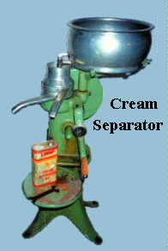

By the beginning of the 1900s farmers brought their milk to the creamery in plate iron milk churns. The creameries then made and sold their own butter.

12. Look at the Information Panel “Mechanisation”

(v) The story of butter making as shown in the panel “Mechanisation” is different from the story of butter making shown in the panel “Butter Making on the Farm”

List three of those differences

The large cylinders in the photographs are butter churns in a creamery;

- Can you identify two differences between these churns and the churns you have seen in the Museum?

Look at the bottom picture of the scene outside the creamery;

- What is happening in this picture?

- Identify one item in the picture that is on display in the Museum?

- What impact do you think the farmers bringing milk to the creamery had on the business of the Cork Butter Exchange?

.

CORK BUTTER MUSEUM – GROUND FLOOR LAYOUT
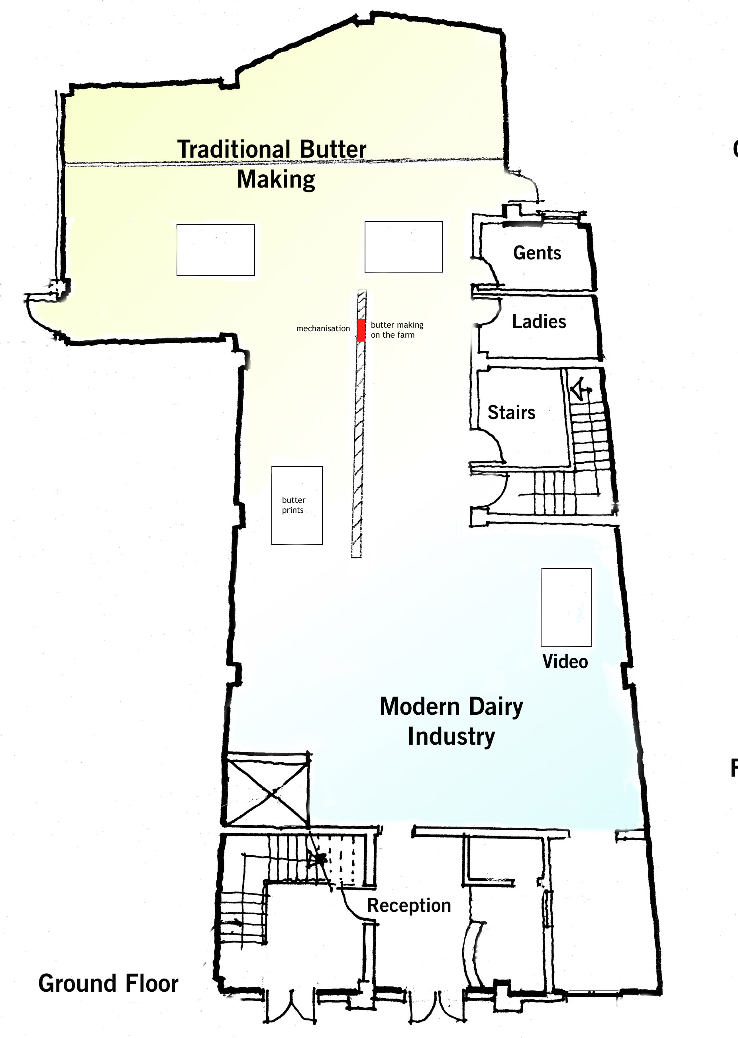

CORK BUTTER MUSEUM – FIRST FLOOR LAYOUT


